**Dengue Disease Detection**

T.Niranjan Babu1, B.Hari Chandana2, Patil Lakshminarayanamma3, Sana Babu Reddy4

1Assistant Professor, 234Student

*JNTUA College of Engineering (AUTONOMOUS):Pulivendula*

*Department of Computer Science & Engineering*

*manikayyachandana99@gmail.com2,lakshmi10.patil@gmail.com3,sanababureddy@gmail.com4*

**Abstract:** Dengue disease is a mosquito-borne disease caused by the dengue virus. Recent research said that there were approximately 390 million dengue infections per year and a major health problem in American and Asia-Pacific regions. This disease is caused by the bite of a mosquito called Aedes aegypt. It is a life-threatening disease and the number of people died due to dengue disease because its symptoms are not detected atthe early stages many people thought that it was a normal fever so that they ignore it which cause leads to dangerous situations and worst case they lose their life. It occurs in two stages: Dengue Fever(DF), Dengue Haemorrhagic Fever(DHC). Early warnings of the dengue outbreak it will help to reduce the disease burden and

to control it. For that symptom and white blood cell classification and classified the dengue as infected or not. In this paper, we compare various machine learning algorithms and found the accuracy of these algorithms for the detection of dengue disease.

**Key Words:** Machine learning - Detection –Dengue Fever – Dengue Haemorrhagic Fever – Symptoms – White blood cells

1. **INTRODUCTION**

Dengue is a major dangerous disease and mostly observed in American and Asia-Pacific regions. World Health Organization(WHO) said that around 50-100 million people had been affected by dengue disease every year worldwide. It is caused by a mosquito-bitten of Aedes aegypt. It is also caused when a mosquito bites a person infected with a dengue virus,the virus enters the mosquito. After being bitten by a mosquito carrying dengue virus When the infected mosquito then bites another person,the virus enters that person’s bloodstream. The disease has an incubation period of 3 to 15 days and begins with flu-like symptoms. In most cases, the disease lasts about 3 to 10 days, but some symptoms and signs may remain and take a long time to disappear. Dengue occurs in two forms:

* Dengue Fever(DF)
* Dengue Haemorrhagic Fever(DHC)

In the dengue fever stage, there is a sudden onset of high fever, severe headache,pain behind the eyes which worsens the eye movement, body aches and joint pains, nausea or vomiting and a characteristic skin rash. This stage will last for six to seven days. But in some cases, the disease leads to the most dangerous life-threatening dengue haemorrhagic fever is a deadly complication with symptoms similar to those of dengue fever. There is a sudden rise in temperature nearly 1050F with convulsions and other flu-like symptoms.There will be a huge reduction in white blood cells. In moderate cases of Dengue Haemorrhagic Fever, all symptoms will be reduced with the relief from fever. In severe cases, the patient’s condition turnsto a worst with the drops intemperature,symptoms of circulatory failure,and thedengue infected person may rapidly go to the state of shock. The Dengue Shock Syndrome(DSS) with the tiny spots of blood on the skin. It also cause bleeding from the nose, blood vomitings. A deadly combination with shock may cause death within 12 to 24 hours. The symptoms for Dengue Haemorrhagic Fever are with the symptoms of dengue fever plus severe pain in the abdomen, severe joint pains, blood vomitings, bleeding from nose, gums, mouth.This will be used for the detection of dengue disease using machine learning algorithms. First of all, we will identify the symptoms of dengue inpatient and the prediction takes place with the identification of symptoms.Classification is done by using datasets and to predict accuracy.

1. **LITERATURE SURVEY**

In all the existing system models there are some drawbacks in those systems. So, we can come with an idea to reduce those drawbacks in the detection of dengue disease.

[1] In this paper, they compare various machine learning algorithms and found the accuracy of those algorithms for the early detection of dengue disease. Data mining is the technique for the classification of diseases like dengue. In this they take the Weka toolbox is used to evaluate and compare the results.

[2] In this paper, the system proposed as the blood images are captured by a digital microscope. In preprocessing, these images contain noise so the median filter is used to remove noise. It is segmented by Morphological thresholding segmentation. In feature extraction, features of a white blood cell nucleus are extracted by the SIFT algorithm. By SVM classifier classify as infected or non-infected.

[3] In this paper, the dengue disease is detected by weather forecasting. The dataset contains attributes like temperature, rainfall, humidity, precipitation, etc.. They are done with Gradient Boosting Regression(GBR) algorithm and the Mean Square Error(MSE) to measure the performance of the model.

[4] In this paper, they develop two sets of Random Forest models for the national and department levels in Colombia to predict weekly dengue cases at 12-weeks ahead. A national model based on artificial neural networks(ANN) was also developed and used as a comparator to the Random Forest. The various predictors included historic dengue cases, satellite-derived estimates for vegetation, precipitation, air temperature and population counts. This study showed the potential of Random Forest in dengue forecasting with also demonstrating the feasibility of using a national model to forecast.

[5] In this paper, they not only recognize the increasing numbers of human infections but also that they may cause neurological and other clinical complications with fatal sequences. In this they attempt to highlight some of the features in the context of dengue virus pathogenesis.

1. **LACUNA IN EXISTING SYSTEM**

There will be an existing system for dengue detection based on weather forecasting. The system is like with attributes temperature, rainfall, humidity is the major attributes for the mosquitoes to flourish. So, they take the attributes Temperature, population, Precipitations, Urbanization, Temperatures to detect the dengue disease. It gives the result only according to the area weather conditions. But the dengue disease can’t be decided upon weather condition but the dengue disease will be detected based upon symptoms of dengue disease.

1. **METHODOLOGY**

In the proposed system, the prediction of dengue disease is going to do by getting from different hospitals.The datasets contain information about the number of dengue fever cases. It contains information about the symptoms of different dengue infected persons. The symptoms are fever, vomiting(with or without blood), nausea, body pains, pain behind eyes, joint pains, chill, headache, swollen glands, rashes, abdominal pain, bleeding nose, bleeding mouth, fatigue, red eyes, and platelets count. It includes dengue heamorrhagic fever, characterized by high fever.

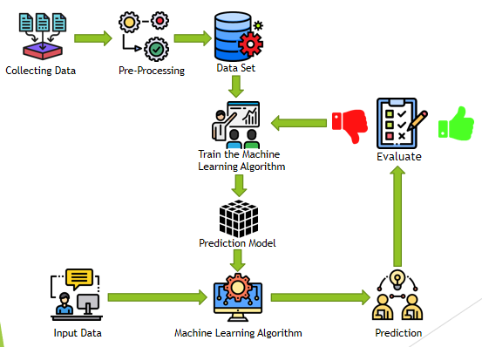

**Fig-1: Architecture**

First of all, collect the data from different hospitals.

* 1. **Pre-processing**

The dataset contains all the information which the learning model is supposed to learn for making the right predictions. The raw data might have a number of different values of each attribute which might lead to incorrect results. Therefore the information must pre-process by the learning process.

The pre-process includes the following:

The data set contain a lot of missing values. These missing values results in improper learning,these can be handled by following ways:

1)Filling the missing values: The missing values in the dataset must be filled with the most occurring data values in the data set for the attribute.

2)Removal of Data instances: The instances which contain missing values for any attribute must be removed. By this, we removed the unreliable data from the data set. So, by this technique, the number of data instances must be reduced. Hence this method can be implemented for large datasets.

**Conversion to numerical values:**

The attributes that contain string values need to convert into numerical values. In the dataset, the attribute body pains have high, mild, low values. This can be converted into numerical data by using get method by assigning low=0, mild=1, high=2.

**Data Cleaning:**

In the dataset, there can be some attributes which don’t have an effect on the results. Such attributes need to be identified and can be removed from the dataset to simplify the dataset.

In our dataset, the id is the redundant attribute. Hence the attribute id was dropped and not considered for the analysis of the data.

* 1. **Implementation – Prediction:**

In the prediction process, we get the output by giving all the values of symptoms. For generating the output the dataset is compulsory, given below is the sample dataset.

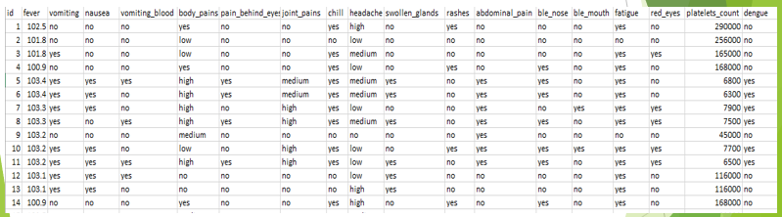

**Fig-2: Data set**

**Algorithm:**

In our dengue disease detection Model, we are mainly using two algorithms and they are:

* Decision Tree
* Random Forest

Random forests is an ensemble decision tree approach. A decision tree is a simple representation for classification in which each internal node corresponds to a test on an attribute, each branch outcome of a test, and each leaf holds a class label. Random Forest requires training each decision tree with a randomly selected subsample of the entire training datasets.

* 1. **UI**

We design UI for the dengue detection it takes all the symptoms and gives output.

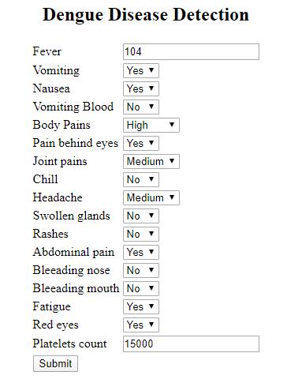

**Fig-3: UI**

1. **RESULT AND ANALYSIS:**

We compare the various algorithms and with the algorithms Decision tree and Random Forest we get more accuracy. With the help of historical data we get result if the patient is infected or not. If the symptoms of patient is given to the UI it take the values and in the background it will analyse all the dengue cases and gives the output if the patient is affected with dengue disease or not.

We will take one dengue affected and dengue unaffected case.



**Fig-4: Dengue affected case**



**Fig-5:Dengue unaffected case**

So, by giving all the symptoms of the patient it gives the result.

1. **CONCLUSION**

The proposed system is based on the symptoms of dengue disease and it is used to avoid the mistakes or errors of lab technicians. In this the sequence takes place as pre-processing, train the algorithm, prediction, evaluation. In this by taking historical dengue cases to predict to detect the infected or non infected using Random Forest and Decision tree.

1. **REFERENCES**

[1] N.Rajathi, S.Kanagaraj, R.Brahmanambika, K.Manjubarkavi “Early Detection of Dengue Using Machine Learning Algorithms,” International Research Journal of Engineering and Technology(IRJET) Volume 118

[2] Reenu Marie Philip, Gopakumar “Automated Dengue Detection,” International Research Journal of Engineering and Technology(IRJET) Volume: 05

[3] P.Muhilthini, B.S.Meenakshi, S.L.Lekha, S.T.Santhanalakshmi “Dengue Possibility Forecasting Model using Machine Learning Algorithms,” International Research Journal of Engineering and Technology(IRJET)

[4] Anna L.Buczak, Benjamin Baugher, Linda J.Moniz, Thomas Bagley, Babin, Erhan Guven “Ensemble method for dengue prediction,” PLoS One. 2018; 13(1): e0189988

[5] Rosmari Rodriguez-Roche, Ernest A.Gould, ”Understanding the Dengue Viruses and Progress towards Their Control,” BioMed Research International Volume 2013

[6] Sheng-Fuu Lin, Yu-Bi Hong, ”Differential Count of White Blood Cell in Noisy Normal Blood Smear”,IEEE2011.

[7] Joshi, Ms Minai D.,Atul H.Karode, and Classification to Detect Acute Leukemia.” International Journal of Emerging Trends & Technology in Computer Science(IJETTCS) 2.3,pp.147-151,2013

[8] Ta-Chien Chan, Tsuey-Hwa Hu, Jing-Shiang Hwang,”Daily forecast of dengue fever incidents for urban villages in a city”,International Journal of Health Geographics,2015.

[9] Anshul Goyal, Rajni Mehta, “Performance Comparison of Naïve Bayes and J48 Classification Algorithms”, IJAER, Vol.7, No.11,2012.

[10] Katz,Alfred RJ. “Image Analysis and Supervised learning in the automated Differentiation of White Blood cells from Microscopic Images.”,2000.

[11] Ashwini Rejintal, Aswini N, “Image Processing Based Leukemia Cancer Cell Detection”, IEEE International Conference on Recent Trends In Electronics International Conference on ICT and Knowledge Engineering.